WRITE ON, BIG REDS!
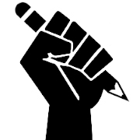
Or, Sexton’s Focus on Writing in 2014-15

Why Writing Matters
- It’s everywhere – assignments, schedules, music, TV, smartphones, menus, directions, etc.
- It helps you think better and more clearly about things
- It’s a skill that can help you get a job, keep a job, and move up in your job
- It’s a skill that can help you get into college
- There are really amazing careers out there that require you to be a good writer – you could be hired by the NBA to write stuff for their teams, or you might create the ads or shows you see on TV, or you could become a Supreme Court lawyer who writes decisions that affect all Americans, or you could write all of the rules that people have to follow at their workplace, or … there are too many to list!
- Journal writing can help you feel better about what’s going on in your life
- Communicating in writing is sometimes easier than doing so in person – you’ll want to be able to express yourself clearly.
- Being good at writing will help you get better grades in all of your classes, not just in English class.

The Plan
- Take a “pre-assessment” so we can see what you’re already good at and what things you need to work on to become a better writer.
- The focus is on informative and explanatory writing this year. This means you’ll get really good at writing stuff that teaches people about topics or explains how to do something or how something works.
- We’ll work on small parts of writing at a time so you don’t have to worry about getting great at everything all at once.
- We want writing to be fun, so we’ll offer some opportunties to write poetry, stories, articles about sports or music, ad campaigns, you name it. You may even choose to write a novel! Watch for more details in the coming weeks.
- Take a “post-assessment” to see how much your writing has improved after practice and hard work.

“A true piece of writing is a dangerous thing. It can change your life.” – Tobias Wolff

“You write in order to change the world…if you alter, even by a millimeter, the way people look at reality, then you can change it.” - James Baldwin

Informative/Explanatory Writing Prompt

Great historical events often have deep effects upon the people who live through them. Depending on the person and the situation, those effects can be very different – or not. The civil rights movement in the United States contained many of these events.
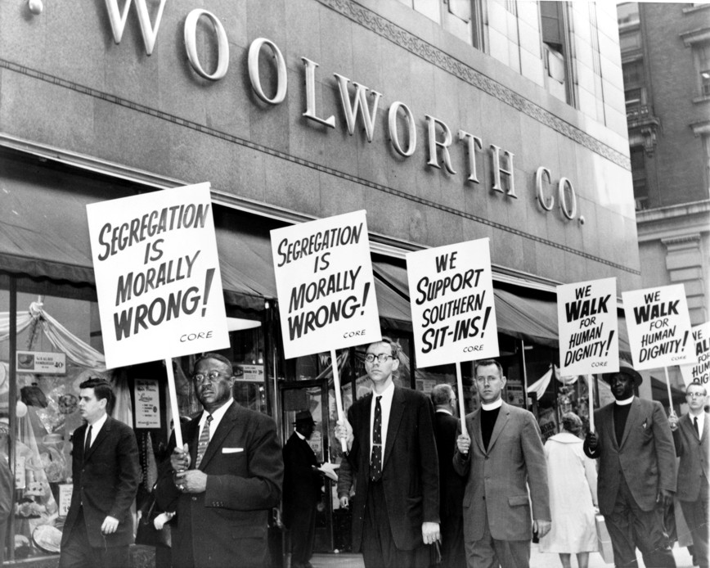
You are going to read three texts about the civil rights movement: an introduction to the Montgomery bus boycotts in the 1950s, a poem called “I, Too, Sing America” by Langston Hughes, and a 2013 article about the only white woman to die during the American civil rights protests of the 1950s and 1960s. As you read and re-read these texts, think about what the texts show you about how the American civil rights movement seems to have affected the individual people who lived through it.
Finally, using these texts, you will write an essay, explaining your thinking.
For your essay, your focusing question is:
According to these texts, what effect did the American civil rights movement have on people who lived through it? Be sure to use evidence from the texts to support and develop your thinking.

Freedman, Russell. Freedom Walkers: The Story of the Montgomery Bus Boycott. New York: Holiday House, 2006.
From the Introduction: “Why They Walked”

Not so long ago in Montgomery, Alabama, the color of your skin determined where you could sit on a public bus. If you happened to be an African American, you had to sit in the back of the bus, even if there were empty seats up front.

Back then, racial segregation was the rule throughout the American South. Strict laws—called “Jim Crow” laws—enforced a system of white supremacy that discriminated against blacks and kept them in their place as second-class citizens.

People were separated by race from the moment they were born in segregated hospitals until the day they were buried in segregated cemeteries. Blacks and whites did not attend the same schools, worship in the same churches, eat in the same restaurants, sleep in the same hotels, drink from the same water fountains, or sit together in the same movie theaters.

In Montgomery, it was against the law for a white person and a Negro to play checkers on public property or ride together in a taxi.

Most southern blacks were denied their right to vote. The biggest obstacle was the poll tax, a special tax that was required of all voters but was too costly for many blacks and for poor whites as well. Voters also had to pass a literacy test to prove that they could read, write, and understand the U.S. Constitution. These tests were often rigged to disqualify highly educated blacks. Those who overcame the obstacles and insisted on registering as voters faced threats, harassment. And even physical violence. As a result, African Americans in the South could not express their grievances in the voting booth, which for the most part, was closed to them. But there were other ways to protest, and one day a half century ago, the black citizens in Montgomery rose up in protest and united to demand their rights—by walking peacefully.

It all started on a bus.
__________________________________________________________________________________________________Hughes, Langston. “I, Too, Sing America”
I, TOO, SING AMERICA
I, too, sing America.
I am the darker brother.
They send me to eat in the kitchen
When company comes,
But I laugh,
And eat well,
And grow strong.
Tomorrow,
I'll be at the table
When company comes.
Nobody'll dare
Say to me,
"Eat in the kitchen,"
Then.
Besides,
They'll see how beautiful I am
And be ashamed--
I, too, am America.

_____________________________________________________________________________ Killed For Taking Part In 'Everybody's Fight'
by KAREN GRIGSBY BATES, August 12, 2013, National Public Radio

In an obscure corner of Detroit, there's a battered playground honoring a civil rights martyr. It has an overgrown baseball field, some missing swings and on a broken fence, a worn, wooden sign.

"It's all tore up and definitely could use at least a paint job," says Sally Liuzzo-Prado. She is referring to the sign with her mother's name on it.

Liuzzo-Prado was 6 when her mother, Viola Liuzzo, was killed by Ku Klux Klan members following a voting rights march in Alabama in 1965. Liuzzo was the only white female protester to die in the civil rights movement.

The housewife and mother of five had been an active NAACP member in Detroit and was horrified at the violence she saw inflicted upon black protesters on television. So when she heard of a four-day, 54-mile walk from Selma to Montgomery, Ala., to support voting rights, she packed a bag. Liuzzo told her husband: "It's everybody's fight." She kissed her children goodbye and began the drive south.

"She called us every night. I learned how to cursive write and she was so excited. She told me to write my name and put it on her dresser and she'd see it when she got home," says Liuzzo-Prado.

Led by the Rev. Martin Luther King Jr., Viola Liuzzo and thousands of other marchers walked to Montgomery, where King spoke on the Capitol steps, telling the crowd that freedom was imminent: "How long? Not Long! Because no lie can live forever. How long? Not long!" King said in a now-famous speech.

That night, Liuzzo, tired but exhilarated, shuttled local marchers back to their homes. A car filled with Ku Klux Klan members tried to force her off the road. Finally, they pulled alongside Liuzzo's car and shot her in her head. The 39-year-old died instantly.

King attended Liuzzo's funeral and comforted her family, but not everyone agreed that she was a hero. A group of people tried to break down the Liuzzos' door, and a cross was burned on their lawn. What Sally Liuzzo-Prado remembers most vividly is the morning she returned to first grade after her mother's death. She was wearing her saddle shoes, which her older sister, Penny, had polished.

"It was pouring rain that day. And I looked down at my saddle shoes and the white polish was coming off," she says. "These people — grown-ups — lined the street and were throwing rocks at me, calling me 'N-lover's baby.' I didn't know what that meant. I thought it was because of my shoes."

